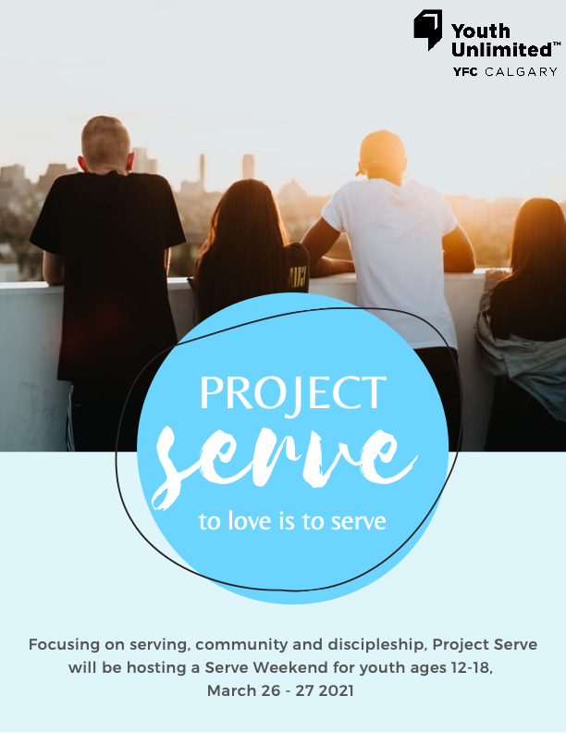
TABLE OF CONTENTS

What is Project Serve? 3
Our Pursuits 3
Our Mission 3
SERVE WEEKEND MARCH 2021 3
Weekend Schedule 4
Serve Activities 5
Evening Activities* 6
IMPORTANT INFORMATION 6
Dates 6
Cost 6
Steps to Register 7
Other 7
QUESTIONS 7

What is Project Serve?

Project Serve Calgary provides young people the opportunity to serve God through serving others with the vision to build up a generation of servant hearts who understand the brokenness in their own city and are connected to various local organizations involved in applicable relief ministry.

This spring break Varsity Bible Church and Project Serve will be hosting a SERVE WEEKEND - which we are SO excited about! This weekend will be aligned with our mission and public health regulations so that everyone can serve safely.

Our Pursuits

Expose To open the eyes of youth to the needs and brokenness in their city.
Educate Training youth to practically work towards solving social injustices by partnering with established ministries.
Empower Providing youth opportunities to get involved with local ministries.
Engage To have youth fully engaged in service for long term local impact.

Our Mission

From past mission trips, we’ve noticed how impactful a mission trip in the youth’s own city can be; young people not only get the opportunity to see the needs within their own community but can continue volunteering beyond the one/two-week trip!

Therefore, our mission is to facilitate lasting relationships between church youth ministries and local charitable organizations in order to engage the youth in continuing compassionate service to those in need.

SERVE WEEKEND MARCH 2021

Serve Weekend will be focused on serving our communities, growing in our faith, and growing in community. Open to all Varsity Bible Church youth and friends in grades 7-12. Space is limited so make sure to register early to reserve your spot!

Weekend Schedule
The following schedule is subject to change based on COVID restrictions. A final schedule will be sent out to all participants prior to the Serve Weekend.

Friday
4pm Meet at Varsity Church
Check in
Meet team
Community building activities
Service activity #1
6pm Supper
6:30pm Chapel
Team discussions
7:30pm Evening Activity (Parents and families encouraged to participate)
9pm Wrap up

Saturday
9am Meet at service location
Check in
Group devotions
Group prayer
Team activities
10am Service activity #2
1pm Lunch
Afternoon break*
6:30pm Check in
Chapel
Team Discussions
7:30pm Evening Game (Parents and families encouraged to participate)
9pm Wrap up

*During the afternoon break youth will be required to go home (youth will not be able to stay at the service locations). Teams will meet again at 6:30pm for check in at Varsity Bible Church.

Serve Activities

Project Serve has focused on partnering with existing organizations so that youth can build a lasting relationship and continue serving year-round. Last year, due to COVID, we focused on serving organizations through the safety of our own home and specifically serving our neighbors. Here are a few examples of what we have done in the past:
- Serving Calgary Organizations:
  - L’Arche – In previous summers we have done painting, coffee houses, and visited with residents at L’Arche. Last summer we created online encouraging videos for program members who have felt isolated during the pandemic.
  - Youth Unlimited – In past summers we have cleaned and cooked for Youth Unlimited’s Streetlight ministry.
  - Senior Homes – we have served residents and staff in Senior homes by visiting with residents, creating fun activities for residents, writing encouraging letters, and by creating art for residents.
  - Monday Night Evangelism – Partnering with MNE, we have gone out on the streets and shared food, conversation, and the gospel with others.
  - And many more including Meals on Wheels, Jesus Loves You Society, Hope Mission, The Mustard Seed, Calgary Drop-in Centre, and The New Canadian Friendship Centre.
- Serving our neighbors:
  - Neighborhood clean up,
  - Mowing lawns,
  - Outdoor landscaping,
  - Collecting and donating gently used clothing,
  - Writing encouraging sidewalk chalk notes around our neighborhoods,
  - And more!

All planned activities will adhere to all government regulations during the Serve Weekend.

Evening Activities*

Evening activities have served as a fun way to connect, debrief, and grow as a community. The Project Serve team works really hard to make these EPIC for all participants. Past evening activities have included:
- City-wide Amazing Race
- City-wide Gold Hunt
- Online ‘The Price is Right’
- Campfire & S’mores roast
- Wide games at a park
- And many more!

We are planning some awesome new and old evening activities that will blow your mind!!

*Due to COVID regulations youth will need parents to drive them for evening activities. Please meet your youth at Varsity Bible Church at 7:30pm Friday and Saturday evening. Parents and families are encouraged to participate as a team.

IMPORTANT INFORMATION

Dates

March 15th – Registration Opens

March 22nd – Registration Closes

March 26th & 27th – SERVE WEEKEND

Cost
$35/Youth
If cost is an issue, please contact us and we would love to help you!

Steps to Register
- Visit yucalgary.ca/serve-wknd2021
  - Fill out registration form
  - Pay for registration
  - Fill out Project Serve waivers online
    - Participant Waiver & release form
    - Photo & Media Release Form

Once your registration is complete you will receive a confirmation email from the Project Serve team within 1-2 business days.

Other
- Youth are required to bring: Mask(s), hand-sanitizer,
- Youth are asked to pack a lunch and snack on Friday. Please no nuts, tree nuts, or peanuts.
- Youth will be required to submit an online check in prior to the start of Friday and Saturday events.

QUESTIONS

If you have any concerns or questions please do not hesitate to contact the Project Serve team, we would love to talk to you!

Email: projectservecalgary@yfc.ca
Phone: 1 888 753 8575 ext. 111

